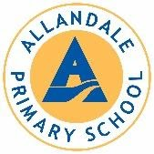

TRUSTEE REMUNERATION AND EXPENSES

RATIONALE

The board has the right to set the amount that the chair and other board members are reimbursed for attendance at board meetings in recognition that these fees cover the expense of attending board meetings. The principal, as a member of the board is entitled to the same payment as all other trustees except the chair.

GUIDELINES

Currently at Allandale School:

- The chair receives $75.00 per board meeting.
- Other board members receive $55.00 per board meetings.
- There is no payment for working group/committee meetings.
- Attendance fees are non-taxable within the agreed non-taxable amounts of $605 annually for trustees and $825 for the chair.
- Attendance costs for professional development sessions will be met by the board of trustees. Prior approval must first be sought.
- All other reimbursements are at the discretion of the board and must be approved prior to any spending occurring.

